Practical 14: Admin Dashboard with Role-Based Access Control, Dynamic Menu, and Audit Log
Problem Definition Develop an admin dashboard that displays user statistics, student count,
event count and latest registrations. Restrict access to admin users only
and show dynamic menu options based on role.

Theory :

Key Questions / Analysis / Interpretation
1. Are dashboard values loaded dynamically from the database?
Yes. Dashboard values are fetched dynamically from the database using PHP and MySQLi.
2. Is access restricted to admin users?
Yes. Only authenticated users with the admin role can access the admin dashboard.
3. Are role-based menus working?
Yes. Different menus are displayed according to the user's role and access permissions.
4. Are important admin actions recorded in audit_logs?
Yes. Important admin actions, such as adding, updating, and deleting records, are recorded in the audit_logs table for tracking and monitoring.

Implementation/out put/result:
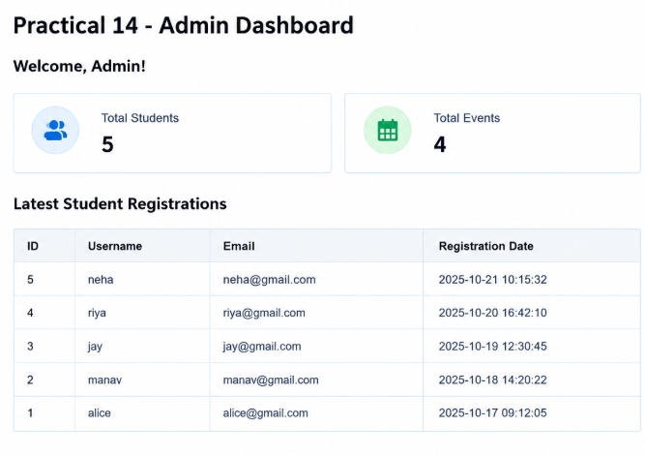

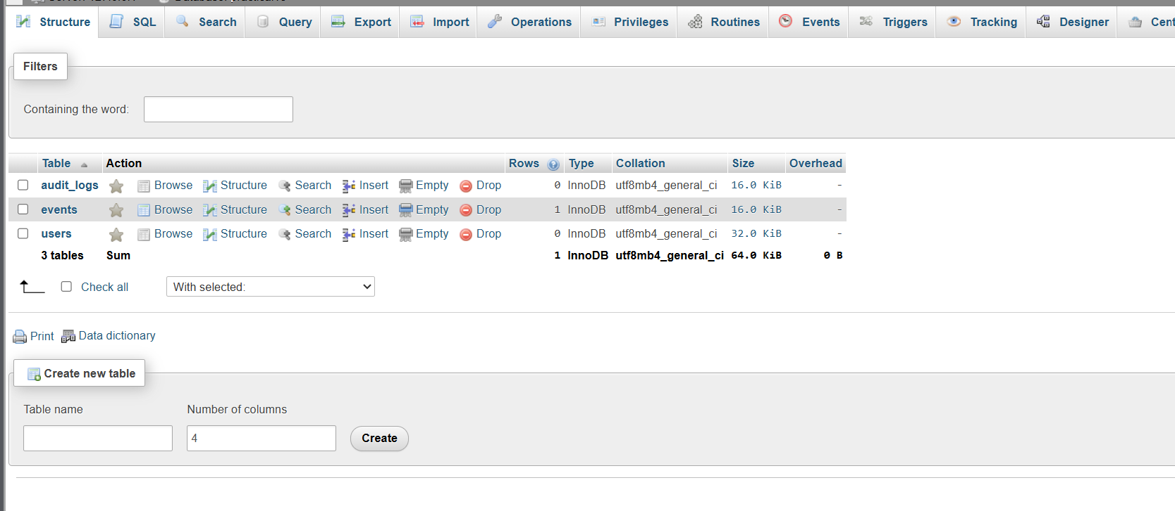

Git hub link:
https://github.com/nidhisavalia/25dce103-web

Learning outcomes:

Learned to load dashboard values dynamically from a MySQL database.
Learned to restrict admin dashboard access using role-based authentication.
Learned to display menus according to user roles and permissions.
Learned to record important administrative actions in the audit_logs table.
Learned to improve application security and monitor administrative activities.
Learned to manage dashboard data using PHP and MySQLi.

Faculty remarks:

